Freight Maintenance

Purchase Order Freight Maintenance
This screen will allow the user to add freight charges to open Purchase Orders, as well as the vendor code for the freight carrier for the order.
Only users with Purchase Order entry authority can add or change freight charges or freight vendors. ALL other users have inquiry ability only.
Purchase Orders can be limited to only un-received Purchase Orders or all Purchase Orders.
The display of Purchase Orders can Exclude, Include, or Include Only Direct Ship Purchase Orders.
The Purchase Orders can be displayed in vendor or Requested date sequence.
Purchase Orders to be shipped Pre-Paid (freight terms code PP) are excluded from this display.
And only un-received Purchase Orders can have freight vendor or freight amount added or changed.

Color codes- :
RED - Detail lines displayed in red are Purchase Orders with at least 1 Hazmat item included.
YELLOW - If the weight column is displayed in yellow, some or all of the Purchase Order has been received, and the weight displayed is the weight remaining on the Purchase Order.
BLUE - If the Vendor name is displayed in blue, this is a secondary Ship-from for this vendor, not the vendor's primary location.
TURQUOISE - If the Requested date is displayed in turquoise, the Requested date for this Purchase Order has been confirmed with the vendor.

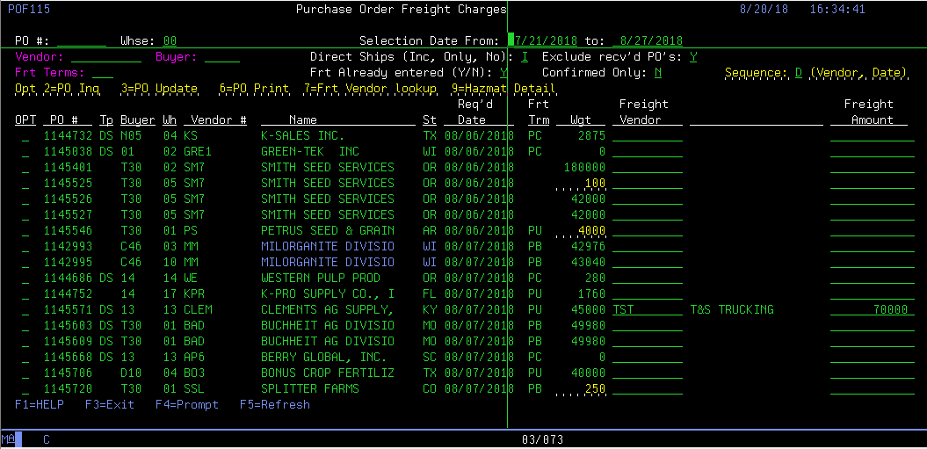

Buyer number
5-position A/N
This field contains the buyer number to restrict this selection to. Leave this field blank to include purchase orders for all buyers.
If the buyer code to select is not known, you may look up the buyer code by placing the cursor in the buyer field and pressing F4.

Purchase Order Location
2-position, A/N
This field will default to your preselected warehouse assignment. For some it may be left as 00 to include all warehouses.

Select FROM Date
8-position, MMDDCCYY
This field contains the FROM selection Date.
Select TO Date
8-position, MMDDCCYY
This field contains the TO selection Date.

Vendor number
10-position, A/N
This field contains the vendor number that you have restricted this selection to. Leave this field blank to include purchase orders for all vendors.
If the vendor number to select is not known, you may look up the vendor number by placing the cursor in the vendor field and pressing F4.

Freight Terms
3-position, A/N
This field contains the freight terms code that you have restricted this selection to. Leave this field blank to include purchase orders for all freight terms codes.
Purchase Orders to be shipped Pre-Paid (terms code PP) are always excluded from this display.
If the freight terms code to select is not known, you may look up the terms code by placing the cursor in the terms code field and pressing F4.

Beginning Purchase Order
7-position, N
This field contains a Purchase Order number that you selected to begin the list at. Leave this field blank and the list will begin with the first purchase order that fits all other selection criteria.

Include Direct Ship Purchase Orders
Do you want to include or Exclude Direct Ship Purchase Orders with this selection.
The default is to include Direct Ship Purchase Orders with all Purchase Orders.
Select from the below options.
I = Include Direct Ship Purchase Orders.
O = Include only Direct Ship Purchase Orders.
N = Do not include Direct Ship Purchase Orders.

Exclude received Purchase Orders
Enter Y to exclude Purchase Orders that already have any items already received
Enter N to include Purchase Orders that have items received.
The default is Y - exclude Purchase Orders that already have any items received.

Freight Already entered (Y/N)?
Enter Y to include Purchase Orders that already have freight charges added. Enter N to exclude Purchase Orders that have freight charges added.

Sequence to display Purchase Orders.
Select from the below options.
V = Display in VENDOR, then REQUESTED DATE sequence
D = Display in REQUESTED DATE, then VENDOR sequence
The default is to display in DATE, then VENDOR sequence

Detail List Options Available to select
Select from the below options.
2 = Purchase Order Inquiry.
3 = Purchase Order Update.
6 = Print Purchase Order.
7 = Lookup Freight Vendor code.
9 = Display Hazmat items for Purchase Order.

Changeable fields:
Freight Vendor code
10-position, A/N
Vendor code for the freight carrier to transport this purchase Order. This must be a valid vendor code.

Freight charge amount.
11,2-position, N
Freight charge amount for this invoice. If a freight amount is entered, a valid freight vendor code must also be entered.

